**Assignment 3**

**Name**: SANTHOSH S

**Roll No**: 820519104028

**Team ID**: PNT2022TMID52358

**Project**: News Tracker

**1. IBM Cloud Object Storage**

**Index.html**

<!DOCTYPE html>

<html lang="en">

<head>

<meta charset="UTF-8">

<meta http-equiv="X-UA-Compatible" content="IE=edge">

<meta name="viewport" content="width=device-width, initial-scale=1.0">

<title>IBM cloud storage images</title>

<link rel="stylesheet" href="https://cloud-object-storage-f7-cos-standard-11r.s3.jp-tok.cloud-object

-storage.appdomain.cloud/style.css">

</head>

<body>

<img

src="https://cloud-object-storage-f7-cos-standard-11r.s3.jp-tok.cloud-objectstorage.appdomain.cloud/The%20city%20Style%20Landscape%2080s%2

0Neon.jpg" alt="wallpaper_1">

<img

src="https://cloud-object-storage-f7-cos-standard-11r.s3.jp-tok.cloud-objectstorage.appdomain.cloud/wallpaper_1.jpg" alt="wallpaper_2">

<img

src="https://cloud-object-storage-f7-cos-standard-11r.s3.jp-tok.cloud-objectstorage.appdomain.cloud/wallpaper_2.jpg" alt="wallpaper_3">

<img

src="https://cloud-object-storage-f7-cos-standard-11r.s3.jp-tok.cloud-objectstorage.appdomain.cloud/wallpaper_3.jpg" alt="wallpaper_4">

<img

src="https://cloud-object-storage-f7-cos-standard-11r.s3.jp-tok.cloud-objectstorage.appdomain.cloud/wallpaper_4.jpg" alt="wallpaper_5">

</body></html>

**Style.css** html{ background-color: rgb(43, 43, 43);

}

body { display: flex; flex-wrap: wrap; gap: 100px; justify-content: center; align-items: center;

}

img { width: 25%;

}

**Screenshot:**

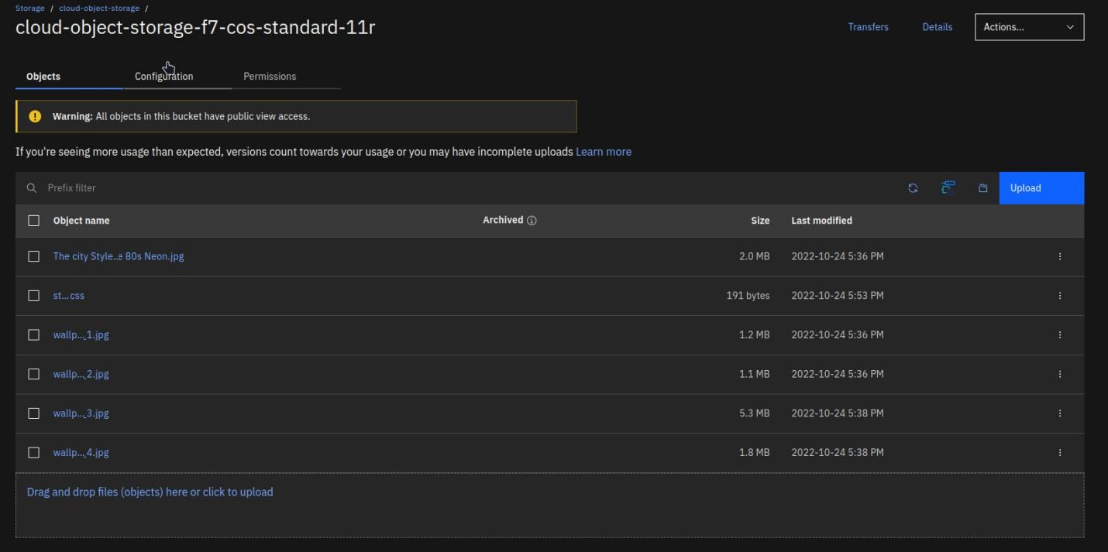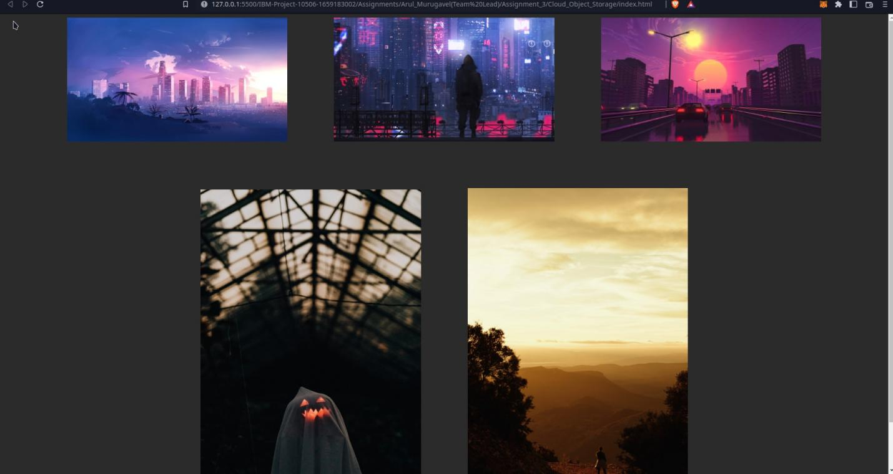

**2. IBM Watson chatbot Chatbot Link:**

[https://web-chat.global.assistant.watson.appdomain.cloud/preview.html?ba ckgroundImageURL=https%3A%2F%2Fau-syd.assistant.watson.cloud.ibm. com%2Fpublic%2Fimages%2Fupx-d968ba26-5f2b-4d9f-a7d6-9794b0d384 eb%3A%3A17de5bce-f970-4e18-833d-a59de2e2a1ab&integrationID=3cb8 aad1-3817-472b-b65f-c1a316d6e9f6&region=au-syd&serviceInstanceID=d](https://web-chat.global.assistant.watson.appdomain.cloud/preview.html?backgroundImageURL=https%3A%2F%2Fau-syd.assistant.watson.cloud.ibm.com%2Fpublic%2Fimages%2Fupx-d968ba26-5f2b-4d9f-a7d6-9794b0d384eb%3A%3A17de5bce-f970-4e18-833d-a59de2e2a1ab&integrationID=3cb8aad1-3817-472b-b65f-c1a316d6e9f6&region=au-syd&serviceInstanceID=d968ba26-5f2b-4d9f-a7d6-9794b0d384eb)

[968ba26-5f2b-4d9f-a7d6-9794b0d384eb](https://web-chat.global.assistant.watson.appdomain.cloud/preview.html?backgroundImageURL=https%3A%2F%2Fau-syd.assistant.watson.cloud.ibm.com%2Fpublic%2Fimages%2Fupx-d968ba26-5f2b-4d9f-a7d6-9794b0d384eb%3A%3A17de5bce-f970-4e18-833d-a59de2e2a1ab&integrationID=3cb8aad1-3817-472b-b65f-c1a316d6e9f6&region=au-syd&serviceInstanceID=d968ba26-5f2b-4d9f-a7d6-9794b0d384eb)

**Screenshot:**

